**Programming fundamentals**

**Lab assignment 3**

**QUESTION#1:**

Explain the output of this C program. Why the wrong value is being displayed in the output?

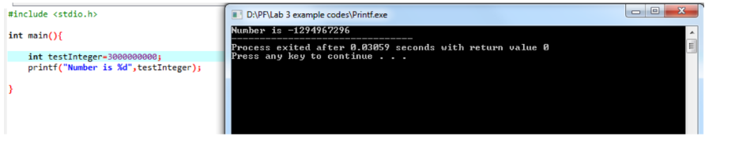

**Answer:**

The int data type in C stores values in 32 bits. In a signed 32-bit integer, the range of values is from -2,147,483,648 to 2,147,483,647. Therefore, the assigned value to the variable testInteger is 3000000000 (which is larger than the maximum value for a signed 32-bit integer).

**QUESTION#2:**

Write a C program that takes two integer values as input from the user. Then swap the values taken from the user and display the output of the variables.

**Source code:**

**Output:**

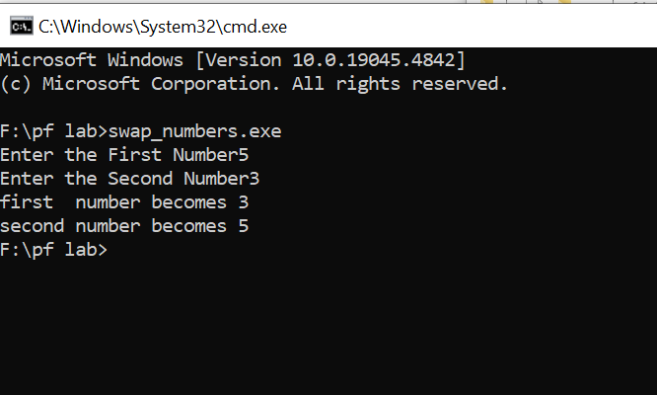

**QUESTION#3:**

A customer asks the IT firm to develop a program in C language, which can take tax rate and salary from the user on runtime and then calculate the tax, the user has to pay and the salary he/she will have after paying the tax. This information is then provided to the user.

**Source code:**

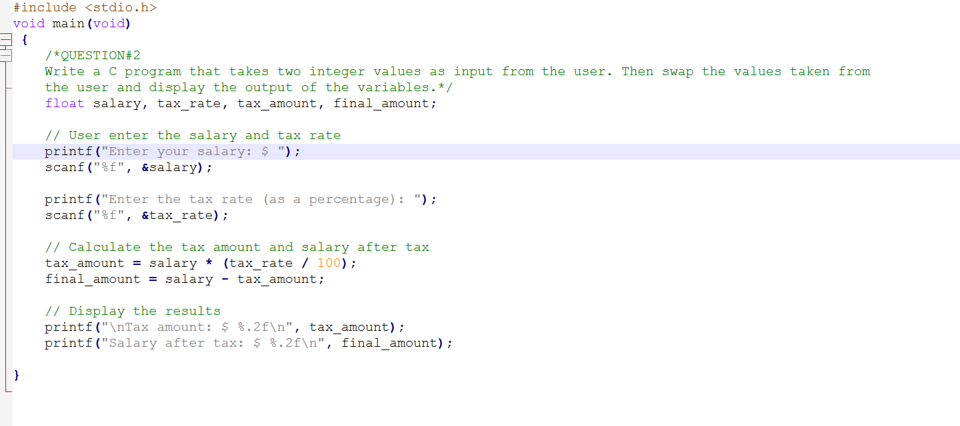

Output:

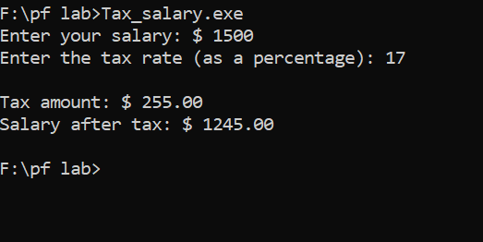

**QUESTION#4:**

A car travelled back and forth from point A to point B. With a distance being (single trip) 1207KM. During the forward trip fuel price was 118/liter while returning it was 123/liter. Calculate the total fuel cost (both ways) and the fuel consumed (total trip). Use the car’s fuel average as input from the user (Input must be positive make some restrictions on only accepting positive input).

**Source code:**

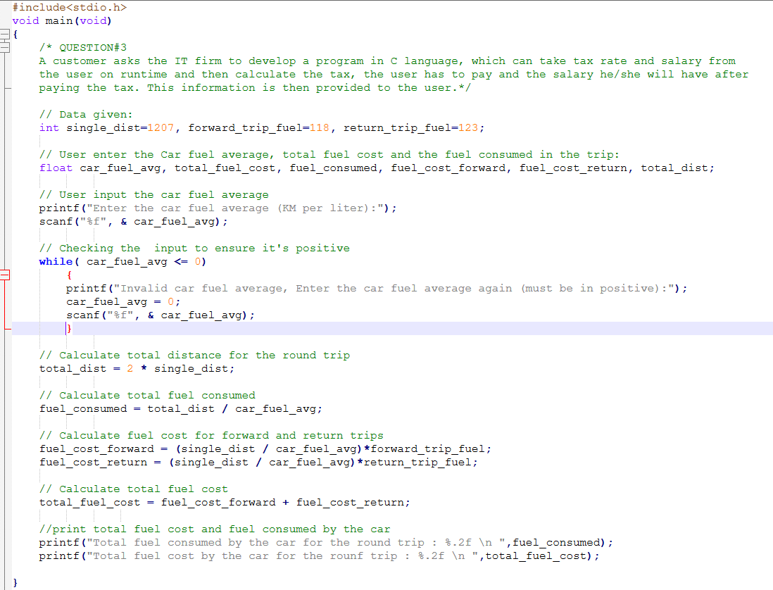

**

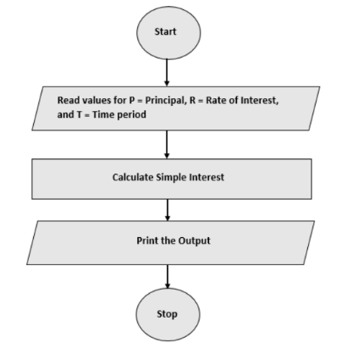

**QUESTION#5:**

Construct a C program with the flowchart below. The input value of the principle must be between 100 Rs. To 1,000,000 Rs. The Rate of interest must be between 5% to 10% and Time Period must be between 1 to 10 years. Hint: these restrictions can be displayed in the form of message on the window.

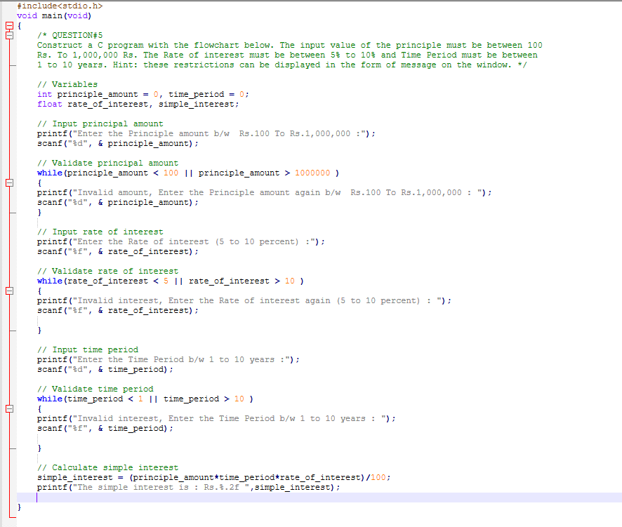

**Output:**

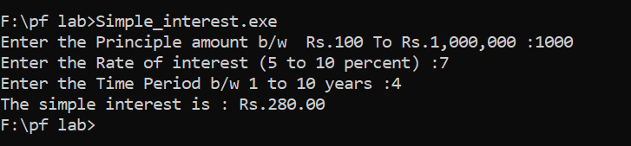

**Question#6:**

Construct a C program where you calculate the slope of two point (5,4), (3,2). Use format specifiers to cap the result to 3 decimal places.

**Source code:**

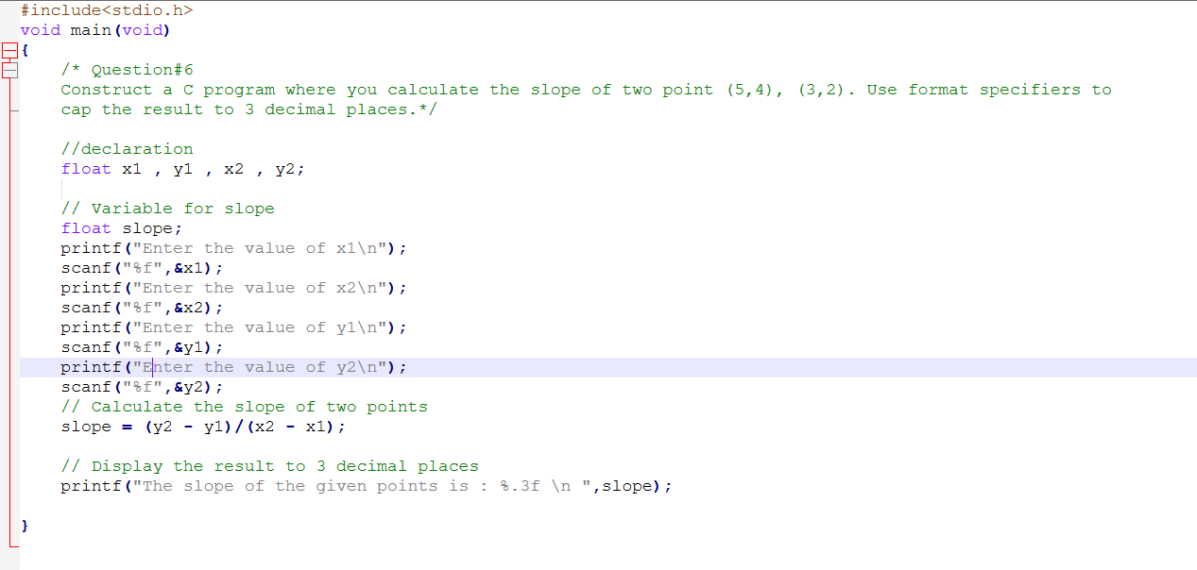

**Output:**

